Table
Table 1. Baseline characteristics of 44 transported and 173 in-house adults patients undergoing ECLS in the same period.
Variables | Transported (n=44) | In-house (n=173) | P
 | No.(%) or Mean$±$SD
Age (y), mean | 47.8 ± 12.3 | 55.4 ± 15.8 | 0.003
Gender, n  Male | 28 (64%) | 110 (64%) | 0.995
Body mass index (kg/m²) | 25.2 ± 5.4 | 24.1 ± 4.0 | 0.147
Underlying diseases  Hypertension  Diabetes mellitus  Coronary artery disease  Congestive heart failure  End-stage renal disease | 9 (21%)  9 (21%)  9 (21%)  8 (18%)  1 (2%) | 58 (34%)  58 (34%)  18 (10%)  31 (18%)  18 (10%) | 0.094  0.094  0.071  0.968  0.133
Primary Diagnoses  Respiratory failure  ARDS from pneumonia  ARDS from other cause  Interstitial lung disease  Others  Cardiac failure  Acute Coronary Syndrome  Decompensated HF  Others | 20 (45%)  13  4  1  2  24 (55%)  12  6  6 | 43 (25%)  17  8  6  12  130 (75%)  42  42  46
ECLS type  Venovenous  Venoarterial | 16 (36%)  28 (64%) | 37 (21%)  136 (79%)
Purpose of ECLS  Bridge to Transplantation  Bridge to Recovery | 8 (18%)  36 (82%) | 23 (13%)  150 (87%)
Cannulation on CPR (ECPR) | 12 (27%) | 68 (39%) | 0.140

Table 2. Transport Data of 44 Patients
Variable | No. or  Mean $±$ SD | Percent or Range
Patients transported on ECLS | 44 | 100
Cannulated by our team | 8 | 18
Event during transportation  Device or mechanical failure  Circuit issue  Hemodynamic compromise  Death on transport | 0  0  0  0 | 0  0  0  0
Mode of transportation  Ambulance  Helicopter | 23  21 | 52  48
Average distance traveled (km) | 178.7 $±$ 152.5 | 13-500
Average time traveled (min) | 74.0 $±$ 52.5 | 15-180

Table 3. Clinical Outcomes
Variable | Transported (n=44) | In-house (n=173) | P
 | No.(%) or Mean$±$SD (Range)
Hospital stay (days) | 47.5 ± 52.0 (2-232) | 30.0 ± 28.5 (2-138) | 0.035
ECLS results  Duration of ECLS (days)  Initial blood flow (L/min) | 17.1 ± 15.4 (2-68)  4.28 ± 1.24 | 8.6 ± 15.3 (1-80)  3.40 ± 0.83 | 0.002  0.001
Outcomes for all patients  Overall ECLS weaning success  Overall Survival to discharge | 33 (75.0%)  31 (70.5%) | 125 (72.3%)  98 (56.6%) | 0.715  0.096
Outcomes for VV ECLS  ECLS weaning success  Survival to discharge | 16  13 (81.3%)  13 (81.3%) | 37  21 (56.8%)  15 (40.5%) | 0.088  0.006
Outcomes for VA ECLS  ECLS weaning success  Survival to discharge | 28  20 (71.4%)  18 (64.3%) | 136  104 (76.5%)  83 (61.0%) | 0.572  0.747
ECLS-related Complications  Critical limb ischemia  (requiring fasciotomy or amputation)  Bleeding (requiring surgical exploration)  Major thromboembolism  Infection (cannulation site, mediastinitis)  Acute kidney injury (requiring CRRT) | 7 (25.0%)*  3 (6.8%)  1 (2.3%)  3 (6.8%)  20 (45.5%) | 11 (8.1%)*  16 (9.2%)  4 (2.3%)  20 (11.6%)  58 (33.5%) | 0.017  0.771  1.000  0.583  0.141
* : were calculated in VA subgroup.

Table 4. Factors Associated with Hospital Mortality (Univariate & Multivariate Analysis)
Variable | Univariate analysis | Multivariate analysis
 | Unadjusted OR (95% CI) | P | Adjusted OR (95% CI) | P
Age, year  Gender (female versus male)  BMI, kg/m² ($≥$25 versus <25)  Transported | 1.029 (1.010-1.048)  0.918 (0.522-1.614)  1.468 (0.841-2.563)  0.548 (0.268-1.119) | 0.003  0.766  0.176  0.096 | 1.027 (1.002-1.053)  1.199 (0.609-2.362)  0.658 (0.276-1.570) | 0.036  0.600  0.346
ECPR  Underlying conditions  Hypertension  Diabetes mellitus  Coronary artery disease  Congestive heart failure  End-stage renal disease | 1.708 (0.975-2.992)  2.189 (1.218-3.933)  1.676 (0.936-3.003)  1.688 (0.752-3.792)  0.787 (0.383-1.615)  2.752 (1.038-7.297) | 0.061  0.008  0.081  0.201  0.513  0.036 | 3.299 (1.515-7.183)  1.981 (0.906-4.331)  1.573 (0.747-3.312)  3.583 (1.165-11.022) | 0.003  0.087  0.236  0.026
Primary diagnoses  ARDS from pneumonia  ARDS from other cause  Acute Coronary Syndrome  Decompensated HF | 1.142 (0.524-2.489)  3.125 (0.911-10.719)  0.474 (0.242-0.927)  1.321 (0.692-2.520) | 0.738  0.072  0.027  0.399 | 3.303 (0.695-15.691)  0.231 (0.092-0.580) | 0.133  0.002
ECLS mode (VV vs VA) | 1.431 (0.767-2.673) | 0.259 | 1.621 (0.673-3.900) | 0.281
Requiring CRRT  ECLS-related complications | 3.624 (2.025-6.484)  1.203 (0.652-2.218) | <0.001  0.554 | 5.790 (2.828-11.855) | <0.001

Fig 1.
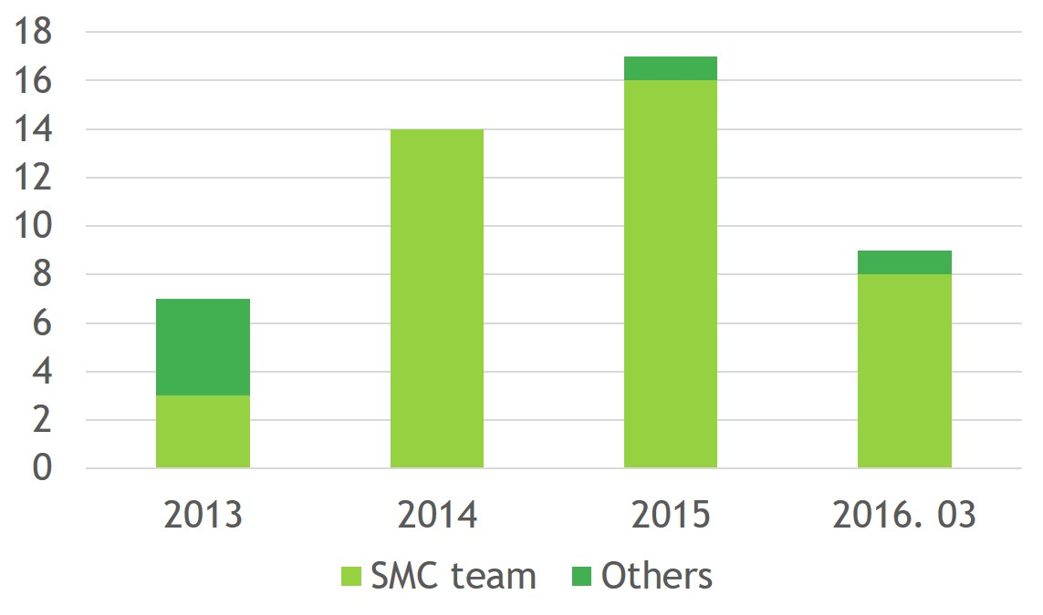
Fig 2.
