Table of legend
 | Total  (n=103) | Group A  4-6mm Tapered  (n=78, 75.7%) | Group B  6mm Straight  (n=25, 24.3%) | p-value
 | N (%)  Mean±SD | N (%)  Mean±SD | N (%)  Mean±SD | p-value
Age at OP. | 62.4±14.5 | 61.1±14.6 | 66.6±13.4 | 0.096
Sex
Male | 48 (46.6) | 38 (48.7) | 10 (40.0) | 0.447
Female | 55 (53.4) | 40 (51.3) | 15 (60.0) | 0.447
Combined diseases
DM | 73 (70.9) | 59 (75.6) | 14 (56.0) | 0.060
HTN | 91 (88.3) | 68 (87.2) | 23 (92.0) | 0.726
CAD | 33 (32.0) | 26 (33.3) | 7 (28.0) | 0.619
PAD | 9 (8.7) | 6 (7.7) | 3 (12.0) | 0.684
CVA | 13 (12.6) | 6 (7.7) | 7 (28.0) | 0.014
Hyperlipidemia | 6 (5.8) | 5 (6.4) | 1 (4.0) | >0.999
Smoking | 17 (16.5) | 14 (17.9) | 3 (12.0) | 0.757
Lab findings
Hemoglobin | 9.7±1.3 | 9.7±1.3 | 9.9±1.2 | 0.591
Hematocrit | 29.2±3.8 | 28.9±3.8 | 30.0±3.8 | 0.183
Creatinine | 6.6±2.9 | 6.6±3.0 | 6.5±2.6 | 0.902
Estimated Ccr | 9.3±4.1 | 9.4±4.1 | 9.1±4.3 | 0.730
Location
Left | 84 (81.6) | 67 (85.9) | 17 (68.0) | 0.072
Right | 19 (18.4) | 11 (14.1) | 8 (32.0) | 0.072
Table 1. Demography of the patients

SD=standard deviation, DM=diabetes mellitus, HTN=hypertension, CAD=coronary artery disease, PAD=peripheral artery disease, CVA=cerebrovascular attack, Ccr=creatinine clearance.

Table 2. Post-operative complications in two groups
 | Total | Group A  4-6mm Tapered | Group B  6mm Straight | p-value
 | N (%) | N (%) | N (%) | p-value
Total complications | 21 (20.4) | 12 (15.4) | 9 (36.0) | 0.026
Ischemia | 3 (2.9) | 1 (1.3) | 2 (8.0) | 0.145
Infection | 11 (18.4) | 6 (7.7) | 5 (20.0) | 0.130
Pseudoaneurysm | 4 (7.8) | 3 (3.8) | 1 (4.0) | >0.999
Seroma | 3 (2.9) | 2 (2.6) | 1 (4.0) | 0.570

Figure of legend
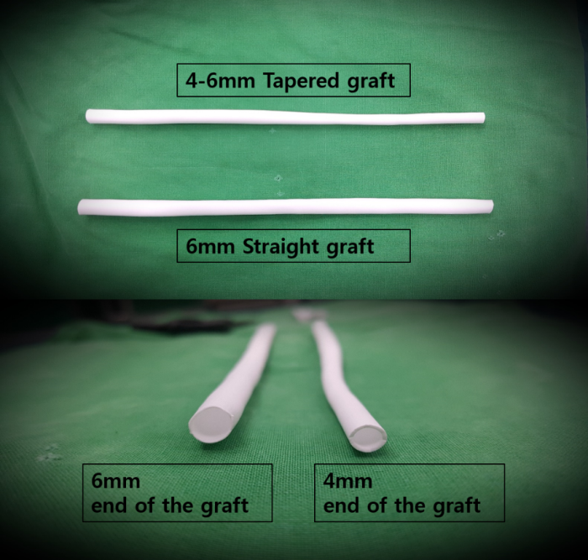
Figure 1. Configuration of 4-6mm tapered graft and 6mm straight graft.

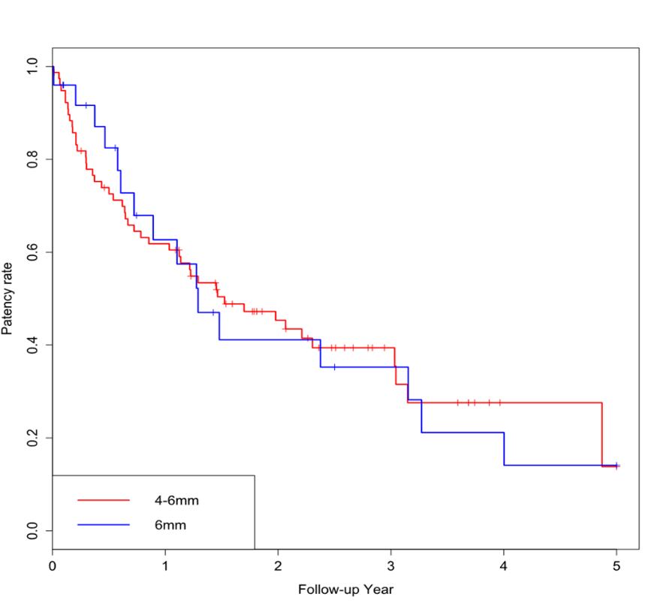
Figure 2. Kaplan-Meier patency rates curves of arteriovenous fistula in Group A (4-6mm tapered) and Group B (6mm straight).

