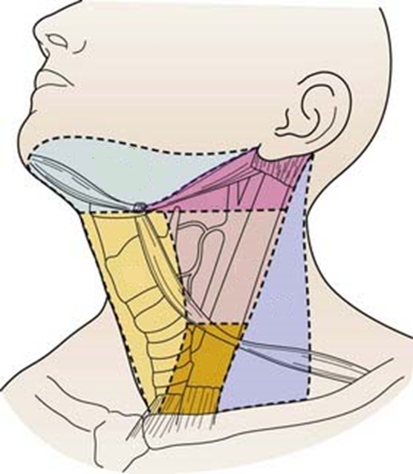
VI
9.1
(1.8)
III
9.1
(1.8)
IV
35.1
(5.1)
V
7.8
(1.8)
I
II
Positive rate (%)
(EI)
Total
44.2
(7.4)

Figure. Regional distribution of node metastasis and efficacy of node dissection according to node levels. (An Original image from Robbins KT, Clayman G, Levine PA, et al: Neck dissection classification update; Revisions proposed by the American Head and Neck Society and the American Academy of Otolaryngology—Head and Neck Surgery, Archives of Otolaryngol Head Neck Surg 128:751–758, 2002, p 752)

Clinicopathological features |  | Univariable analysis |  | Multivariate analysis
 |  | hazard ratio (95% CI) | p | hazard ratio (95% CI) | p
Gender (Male) |  | 0.625 (0.085-4.597) | 0.644
age ≥60 |  | 0.967 (0.494-1.891) | 0.922
Pathologic T stage
pT3/4 |  | 2.559 (1.279-5.123) | 0.008 | 1.731 (0.794-3.773) | 0.167
Pathologic N stage
pN3 |  | 2.852 (1.345-6.049) | 0.006 | 2.039 (0.856-4.859) | 0.108
Differentiation
WD |  | 1.000 | 0.979
MD |  | 0.932 (0.394-2.204) | 0.873
PD |  | 0.894 (0.296-2.700) | 0.843
Location |  |  | 0.207
Upper |  | 1.000 | 0.217
Middle |  | 0.547 (0.262-1.146) | 0.11
Lower |  | 0.977 (0.341-2.801) | 0.966
ECOG
ECOG≥2 |  | 6.595 (1.439-30.224) | 0.015 | 5.872 (1.173-29.388) | 0.031
Comorbidity |  | 0.923 (0.474-1.797) | 0.813
Hypertension |  | 1.101 (0.533-2.273) | 0.794
Diabetes mellitus |  | 1.221 (0.500-2.984) | 0.661
Vocal cord palsy |  | 0.964 (0.485-1.917) | 0.917
Anastomosis leak |  | 1.477 (0.448-4.865) | 0.521
Recurrence |  | 2.474 (1.152-5.316) | 0.02 | 1.402 (0.611-3.215) | 0.246
Cervical metastasis |  | 2.171 (1.057-4.461) | 0.035 | 1.402 (0.611-3.215) | 0.425
Level III |  | 1.371 (0.524-3.589) | 0.519
Level IV |  | 2.361 (1.184-4.708) | 0.015
Level V |  | 0.826 (0.251-2.737) | 0.759
Level VI |  | 1.484 (0.570-3.864) | 0.418
Other levels (I,II) |  | 0.704 (0.168-2.957) | 0.632
Table. Univariate and multivariate analysis of overall survival in patients who underwent 3-FLND (WD : well-differentiated, MD : moderately differentiated, PD : poorly differentiated)

