Table 1. Clinical characteristics of patients
Characteristics | Ultrasonography(-)  (n=124) | Ultrasonography(+)  (n=126) | p-value
Age(yr) | 56.95±14.5 | 56.33±12.4 | 0.714
Sex |  |  | 0.571
Male | 82 (66.1) | 79 (62.7)
Female | 42 (33.9) | 47 (37.3)
Diabetes Mellitus | 68 (54.8) | 79 (62.7) | 0.207
Hypertention | 86 (69.4) | 102 (81) | 0.034
Method |  |  | <0.001
Brachial-Cephalic | 3 (2.4) | 49 (38.9) average(4.8mm)
Snuff box | 84 (67.7)) | 2 (1.6) average(3.9mm)
Wrist | 37 (29.8) | 75 (59.5) average(3.2mm)
Values are presented as mean±standard deviation or number (%).

Table 2. Patency rate according to using sonography
 | Case | 1yr patency | 3yr patency | 5yr patency
Ultrasound (Y) | 126 | 95.2% | 92.9% | 92.9%
Ultrasound (N) | 124 | 79.8% | 76.6% | 75.8%
P-value<0.001

Table 3. Relationship between the venous diameter and early patency(Logistic regression analysis)
Method | p-value | OR | OR 95% confidence interval
Method | p-value | OR | Lower bound | Upper bound
Venous Diameter  (Total) | 0.016 | 6.139 | 1.395 | 27.020
Venous Diameter  (Wrist) | 0.047 | 5.060 | 1.025 | 24.982
Logistic regression analysis has not been performed since 100% success rate was shown in ultrasonography of the Brachial-Cephalic arteries.

Table 4. Correlation efficiency of variable factors
Factors | Proportion | CE | p-value
Age >65 | 27.2% | -0.169 | 0.007
Sex (male) | 64.4% | -0.010 | 0.877
DM | 58.8% | 0.069 | 0.281
HTN | 75.2% | -0.054 | 0.398
CVD ≥3.0mm | 65.9% | 0.191 | 0.009
CE=correlation efficiency

Table 5. Complications
 | Group A(N) | Group B(N) | P-value
Inadequate flow | 0 | 2 | 0.245
Thrombosis | 2 | 2 | 0.683
Venous Hypertension | 6 | 27 | 0.000
Aneurysm | 0 | 1 | 0.496
Infection | 0 | 1 | 0.496
Total | 8 | 33 | 0.000

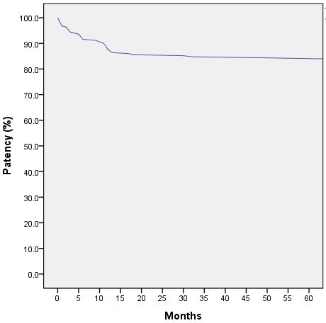
Fig. 1. Overall fistula patency rate. Patency rate had been decreased to 84.4%.

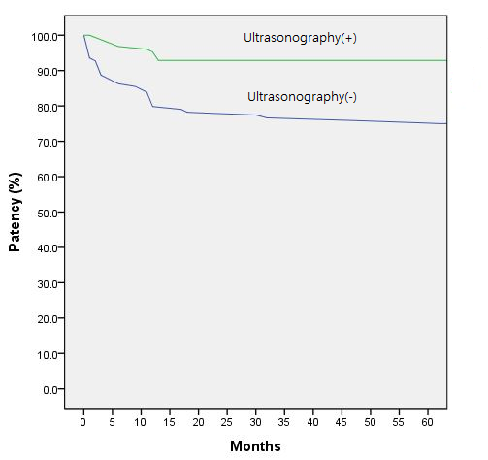
Fig. 2. Difference of Cumulative patency rate according to using ultrasonography preoperatively. A group had patency rate 92.9% and B group had patency rate 75.8%.

p-value=0.006 (chi-square)
Fig 3. 1 year patency rate according to cephalic vein diameter

Fig. 4. 1 year patency rate according to the Vein diameter measured by ultrasonography preoperatively. Cephalic vein diameter less than 3mm group (n=43) had early patency rate 88.4%, and equal or more than 3mm group(n=83) had early patency rate 98.8%.

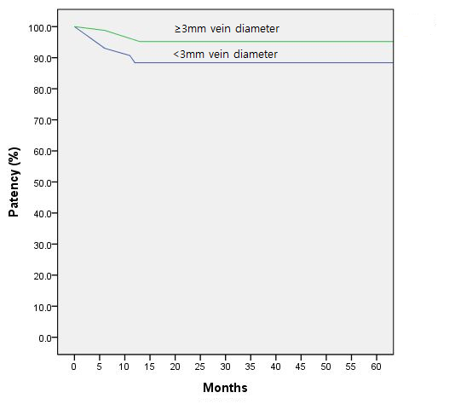
Fig. 5. Difference of Cumulative patency rate according to the vein diameter measured by ultrasonography preoperatively. Cephalic vein diameter less than 3mm group had patency rate 88.4%, and equal or more than 3mm group(n=83) had patency rate 95.2%.

