Figures
Figure 1. IPTW-adjusted Kaplan-Meier estimates of overall survival (P = 0.051).
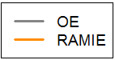
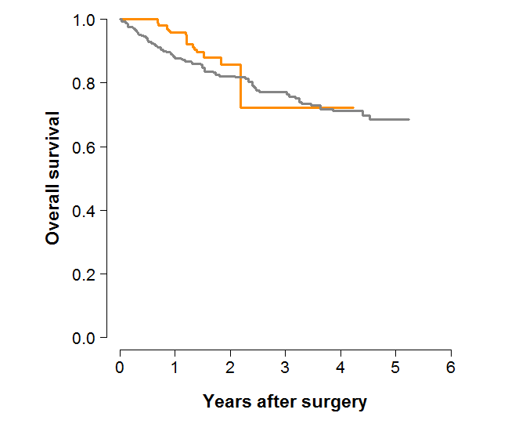

IPTW, inverse probability of treatment weighting; OE, open esophagectomy; RAMIE, robot assisted minimally invasive

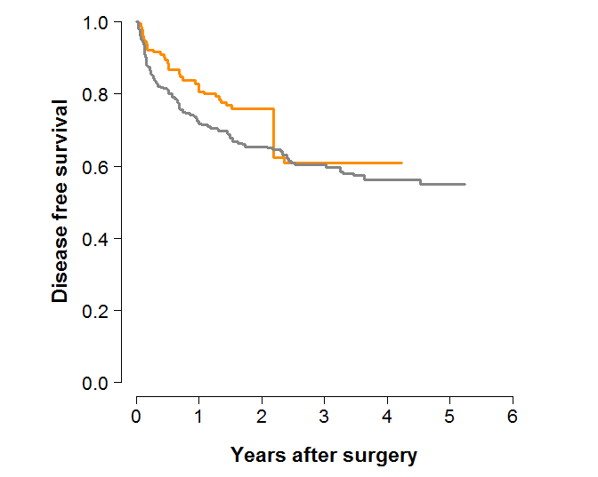
Figure 2. IPTW-adjusted Kaplan-Meier estimates of Disease-free survival (P = 0.217 ).

IPTW, inverse probability of treatment weighting; OE, open esophagectomy; RAMIE, robot assisted minimally invasive

Table 1. Baseline characteristics
 | OE  (n=241) | RAMIE (n=130) | P-value | SMD (%)
Age, years | 62.5 ± 8.0 | 63.7 ± 8.7 | 0.185 | 14.3
Male gender | 223 (92.5) | 118 (90.8) | 0.693 | 6.4
BMI, kg/m² | 23.0 ± 2.8 | 23.6 ± 3.4 | 0.076 | 18.8
BSA, m² | 1.68 ± 0.13 | 1.70 ± 0.15 | 0.264 | 11.9
Smoking | 191 (79.3) | 105 (80.8) | 0.833 | 3.8
Heavy alcohol use | 160 (66.4) | 83 (63.8) | 0.706 | 5.3
Hypertension | 92 (38.2) | 52 (40.0) | 0.816 | 3.7
Diabetes mellitus | 36 (14.9) | 26 (20.0) | 0.271 | 13.4
Hyperlipidemia | 7 (2.9) | 5 (3.8) | 0.856 | 5.2
COPD | 4 (1.7) | 2 (1.5) | 1.000 | 1.0
TBc | 34 (14.1) | 6 (4.6) | 0.008 | 33.0
FEV1 | 89.0 ± 14.2 | 89.6 ± 15.3 | 0.721 | 3.9
Liver cirrhosis | 9 (3.7) | 7 (5.4) | 0.632 | 7.9
GERD | 1 (0.4) | 2 (1.5) | 0.586 | 11.4
H. pylori infection | 2 (0.8) | 2 (1.5) | 0.917 | 6.6
eGFR < 60 | 9 (3.7) | 7 (5.4) | 0.632 | 7.9
Atrial fibrillation | 2 (0.8) | 8 (6.2) | 0.007 | 29.3
History of stroke | 8 (3.3) | 4 (3.1) | 1.000 | 1.4
Coronary artery disease | 1 (0.4) | 6 (4.6) | 0.015 | 27.1
Medications
Anticoagulation | 33 (13.7) | 23 (17.7) | 0.382 | 11.0
Proton pump inhibitor | 6 (2.5) | 4 (3.1) | 1.000 | 3.6
Previous thoracic surgery | 31 (12.9) | 19 (14.6) | 0.755 | 5.1
Symptoms
Dysphagia | 86 (35.7) | 22 (16.9) | 0.001 | 43.6
Odynophagia | 25 (10.4) | 9 (6.9) | 0.363 | 12.3
Tumor location
Upper 1/3 | 69 (28.6) | 45 (34.6) | 0.283 | 12.9
Middle 1/3 | 117 (48.5) | 63 (48.5) | 1.000 | 0.2
Lower 1/3 | 55 (22.8) | 22 (16.9) | 0.229 | 14.8
Neoadjuvant treatment | 102 (42.3%) | 21 (16.2) | 0.001 | 60.1
Clinical TNM stage
1a/b | 123 (51.0) | 95 (73.1) | 0.001 | 46.6
2a/b | 60 (24.9) | 26 (20.0) | 0.349 | 11.8
3a/b/c | 58 (24.1) | 9 (6.9) | 0.001 | 48.8
Operative types
Ivor Lewis | 153 (63.5) | 48 (36.9) | 0.001 | 55.1
Mckeown | 88 (36.5) | 82 (63.1) | 0.001 | 55.1

Values are numbers (%), or mean ± standard deviation, unless otherwise indicated. SMD, standardized mean difference; BMI, body mass index; BSA, body surface area; COPD, chronic obstructive pulmonary disease; TBc, pulmonary tuberculosis; FEV1, Forced Expiratory Volume in 1 second; GERD, gastroesophageal reflux disease; H. pylori, Helicobacter pylori; eGFR, estimated glomerular filtration rate

Table 2. Baseline Balance Table (IPTW)
 | OE  (n=241) | RAMIE (n=130) | P-value | SMD (%)
Age, years | 63.0 ± 7.8 | 63.0 ± 8.6 | 0.988 | 0.2
Male gender | 93.0 | 92.6 | 0.899 | 1.5
BMI, kg/m² | 23.4 ± 2.8 | 23.4 ± 3.3 | 0.870 | 2.3
BSA, m2 | 1.70 ± 0.13 | 1.70 ± 0.14 | 0.912 | 1.4
Smoking | 89.9 | 81.9 | 0.695 | 5.2
Heavy alcohol use | 67.6 | 64.0 | 0.584 | 7.6
Hypertension | 36.6 | 36.7 | 0.989 | 0.2
Diabetes mellitus | 14.2 | 14.4 | 0.960 | 0.6
Hyperlipidemia | 3.1 | 2.6 | 0.812 | 2.6
COPD | 1.2 | 0.8 | 0.626 | 4.3
TBc | 10.8 | 9.5 | 0.799 | 4.3
FEV1 | 89.3 ± 14.3 | 87.7 ± 18.7 | 0.603 | 9.6
Liver cirrhosis | 4.6 | 3.9 | 0.754 | 3.8
GERD | 0.4 | 0.7 | 0.655 | 4.0
H. pylori infection | 0.8 | 0.9 | 0.913 | 1.0
eGFR < 60 | 4.4 | 4.1 | 0.900 | 1.4
Atrial fibrillation | 3.4 | 3.2 | 0.958 | 0.8
History of stroke | 2.7 | 2.4 | 0.866 | 1.8
Coronary artery disease | 2.1 | 2.2 | 0.976 | 0.5
Medications
Anticoagulation | 13.1 | 13.1 | 0.992 | 0.1
Proton pump inhibitor | 2.4 | 2.7 | 0.872 | 1.8
Previous thoracic surgery | 13.7 | 15.1 | 0.788 | 3.9
Symptoms
Dysphagia | 27.9 | 23.9 | 0.565 | 9.2
Odynophagia | 8.3 | 5.7 | 0.364 | 10.1
Tumor location
Upper 1/3 | 29.6 | 27.5 | 0.708 | 4.8
Middle 1/3 | 48.3 | 45.4 | 0.687 | 5.8
Lower 1/3 | 22.1 | 27.1 | 0.462 | 11.7
Neoadjuvant treatment | 32.9 | 25.5 | 0.325 | 16.3
Clinical TNM stage
1a/b | 60.6 | 66.5 | 0.420 | 12.4
2a/b | 21.3 | 18.1 | 0.515 | 8.2
3a/b/c | 18.1 | 15.4 | 0.705 | 7.2
Operative types
Ivor Lewis | 54.4 | 57.1 | 0.700 | 5.3
Mckeown | 45.6 | 42.9 | 0.700 | 5.3

Values are %, or mean ± standard deviation, unless otherwise indicated. SMD, standardized mean difference; IPTW, inverse probability of treatment weighting; BMI, body mass index; BSA, body surface area; COPD, chronic obstructive pulmonary disease; TBc, pulmonary tuberculosis; FEV1, Forced Expiratory Volume in 1 second; GERD, gastroesophageal reflux disease; H. pylori, Helicobacter pylori; eGFR, estimated glomerular filtration rate

Table 3. Operative profiles
Variable | OE  (n=241) | RAMIE  (n=130) | P-value
Resection margins |  |  | 0.719
R0 | 233 (96.7) | 127(97.7)
R1 | 7 (2.9) | 3(2.3)
R2 | 1 (0.4) | 0(0.0)
Lymph node dissection
Lymph node harvested | 38.3 ± 12.9 | 39.1 ± 13.8 | 0.571
Positive lymph node | 0.8 ± 2.0 | 0.7 ± 1.7 | 0.672
Operative time, minutes | 240.0 ± 48.9 | 275.6 ± 71.1 | 0.001
Blood loss, ml | 93.8 ± 140.9 | 110.8 ± 125.8 | 0.251
Thoracotomy conversion | NA | 3 (2.3) | NA
Anastomosis method
Manual | 11 (4.6) | 11 (8.5) | 0.198
Circular stapler | 230 (95.4) | 119 (91.5) | 0.198
Concomitant procedure
Cervical node dissection | 27 (11.2) | 23 (17.7) | 0.113
Pulmonary resection | 33 (13.7) | 3 (2.3) | 0.001
Cholecystectomy | 2 (0.8) | 10 (7.7) | 0.001
Pathologic TNM stage |  |  | 0.003
0/1a/b | 132 (54.8) | 77 (59.2)
2a/b | 71 (29.5) | 39 (30.0)
3a/b/c | 37 (15.4) | 14 (10.8)

Values are numbers (%), or mean ± standard deviation, unless otherwise indicated.

Table 4. Early and long-term clinical outcomes, IPTW-adjusted
Outcomes | OE  (n=241) | RAMIE  (n=130) | P-value
Outcomes | OE  (n=241) | RAMIE  (n=130) | Unadjusted | Adjusted
Postoperative hospital stay, days | 18.2 ± 15.4 | 16.5 ± 9.8 | 0.265 | 0.291
Postoperative ICU stay, days | 1.36 ± 1.97 | 1.08 ± 0.43 | 0.122 | 0.024
Time to oral feeding, days | 10.7 ± 20.3 | 6.8 ± 2.6 | 0.031 | 0.001
Early Outcomes
Early mortality | 4 (1.7) | 0 (0) | 0.342 | 0.174
Early major morbidity | 90 (37.3) | 49 (37.7) | 1.000 | 0.176
Surgical morbidity
Anastomotic leakage | 5 (2.1) | 2 (1.5) | 1.000 | 0.876
Bleeding | 8 (3.3) | 1 (0.8) | 0.242 | 0.036
BPF | 4 (1.7) | 0 (0.0) | 0.342 | 0.168
Chyloperitoneum | 1 (0.4) | 1 (0.8) | 1.000 | 0.652
Chylothorax | 9 (3.7) | 8 (6.2) | 0.422 | 0.970
Conduit necrosis | 1 (0.4) | 0 (0.0) | 1.000 | 0.478
Deep infection | 1 (0.4) | 0 (0.0) | 1.000 | 0.479
Stricture | 0 (0.0) | 3(2.3) | 0.078 | 0.050
Wound problem | 18 (7.5) | 3 (2.3) | 0.069 | 0.003
Vocal cord injury | 48 (19.9) | 33 (25.4) | 0.278 | 0.872
Etc. | 8 (3.3) | 2 (1.5) | 0.500 | 0.717
Pulmonary morbidity
Pneumonia | 26 (10.8) | 5 (3.8) | 0.035 | 0.003
ARDS | 3 (1.2) | 0 (0.0) | 0.503 | 0.220
Prolonged ventilation (> 24 hours) | 20 (8.3) | 7 (5.4) | 0.411 | 0.056
Cardiac complication
Atrial fibrillation | 8 (3.3) | 1 (0.8) | 0.242 | 0.083
Vasopressors | 126 (52.3) | 14 (10.8) | 0.001 | 0.001
Cerebrovascular accident | 1 (0.4) | 2 (1.5) | 0.586 | 0.407
Severity of complication |  |  | 0.141 | 0.135
Grade 0/1 | 151 (62.7) | 81 (62.3)
Grade II/IIIa/b | 77 (32.0) | 48 (36.9)
Grade IVa/b/V | 13 (5.4) | 1 (0.8)
Long-Term Outcomes
All-cause mortality | 67 (27.8) | 14 (10.8) | 0.001 | 0.059
Long-Term major morbidity | 22 (9.1) | 6 (4.6) | 0.173 | 0.055
Conduit-related problem | 8 (3.3) | 5 (3.8) | 1.000 | 0.536
Wound-related problem | 16 (6.6) | 1 (0.8) | 0.020 | 0.001
Composite outcome
All-cause mortality + morbidity | 93 (38.6) | 31 (23.8) | 0.006 | 0.018
Recurrence | 28 (11.6) | 9 (6.9) | 0.208 | 0.191
Locoregional | 18 (7.5) | 6 (4.6) | 0.398 | 0.498
Distant | 12 (5.0) | 7 (5.4) | 1.000 | 0.926
Mixed | 3 (1.2) | 4 (3.1) | 0.402 | 0.184

Values are numbers (%), or mean ± standard deviation, unless otherwise indicated. IPTW, inverse probability of treatment weighting; ICU, intensive care unit; BPF, bronchopleural fistula; ARDS, acute respiratory distress syndrome. Complications were graded according to Calvien/Dindo classification

Table 5. Comparative outcomes
Outcomes | Unadjusted |  |  |  | IPTW-Adjusted
Outcomes | OR/HR* | 95% CI | P-value |  | OR/HR* | 95% CI | P-value
Early Outcomes*
Early major morbidity | 1.01 | 0.65-1.57 | 0.947 |  | 0.68 | 0.42-1.08 | 0.109
Surgical morbidity
Anastomotic leakage | 0.74 | 0.10-3.47 | 0.718 |  | 1.16 | 0.17-6.24 | 0.866
Bleeding | 0.23 | 0.01-1.24 | 0.163 |  | 0.14 | 0.002-0.97 | 0.130
Chyloperitoneum | 1.86 | 0.07-47.3 | 0.662 |  | 1.88 | 0.04-86.42 | 0.697
Chylothorax | 1.69 | 0.62-4.53 | 0.292 |  | 1.02 | 0.36-2.66 | 0.962
Wound problem | 0.29 | 0.07-0.89 | 0.052 |  | 0.16 | 0.02-0.57 | 0.017
Vocal cord injury | 1.37 | 0.82-2.26 | 0.225 |  | 1.05 | 0.61-1.79 | 0.851
Pulmonary morbidity
Pneumonia | 0.33 | 0.11-0.82 | 0.027 |  | 0.23 | 0.06-0.68 | 0.019
Prolonged ventilation (> 24 hours) | 0.63 | 0.24-1.46 | 0.306 |  | 0.41 | 0.12-1.14 | 0.118
Cardiac complication
Atrial fibrillation | 0.23 | 0.01-1.25 | 0.163 |  | 0.19 | 0.002-1.43 | 0.212
Vasopressors | 0.11 | 0.06-0.20 | 0.001 |  | 0.14 | 0.08-0.25 | 0.001
Cerebrovascular accident | 3.75 | 0.36-81.15 | 0.282 |  | 2.70 | 0.19-54.10 | 0.436
Long-term Outcomes**
All-cause mortality | 0.56 | 0.31-1.01 | 0.054 |  | 0.84 | 0.47-1.52 | 0.576
Long-Term major morbidity | 0.74 | 0.29-1.88 | 0.529 |  | 0.64 | 0.24-1.69 | 0.364
Conduit related problem | 1.74 | 0.53-5.64 | 0.358 |  | 2.22 | 0.64-7.74 | 0.209
Wound related problem | 0.16 | 0.02-1.21 | 0.076 |  | 0.06 | 0.002-1.31 | 0.074
Composite outcome
All-cause mortality + morbidity | 0.77 | 0.51-1.17 | 0.218 |  | 0.75 | 0.49-1.15 | 0.187
Recurrence | 0.72 | 0.34-1.53 | 0.397 |  | 0.75 | 0.35-1.75 | 0.509
Locoregional | 0.74 | 0.29-1.87 | 0.526 |  | 0.92 | 0.35-2.45 | 0.873
Distant | 1.31 | 0.51-3.30 | 0.575 |  | 1.37 | 0.50-3.72 | 0.542
Mixed | 2.82 | 0.63-12.6 | 0.175 |  | 3.67 | 0.84-16.15 | 0.085

Values are numbers (%), or mean ± standard deviation, unless otherwise indicated. ICU, intensive care unit; BPF, bronchopleural fistula; ARDS, acute respiratory distress syndrome. Complications were graded according to Calvien/Dindo classification; *Early outcomes are given as odds ratio (OR); long-term outcomes are given as hazard ratio (HR). CI, confidence interval; IPTW, inverse probability of treatment weighting; **Cox proportional hazards assumption (by Schoenfeld residuals)

