Fig. 1 patients population
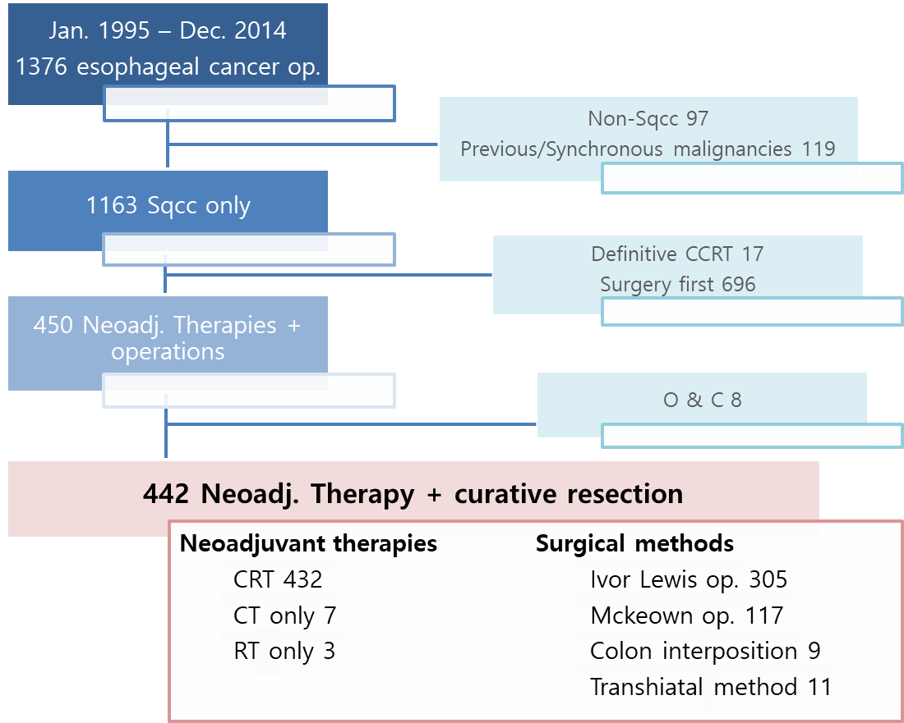
Fig. 2 Overall survival by stage
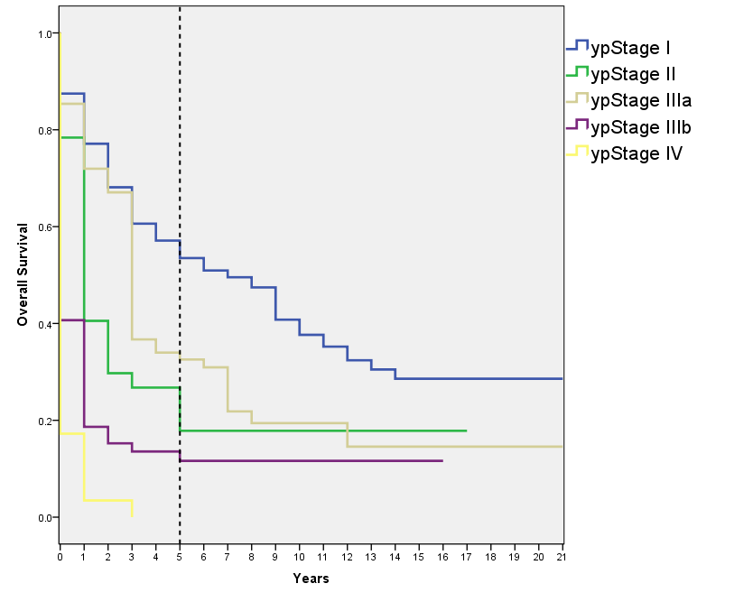
Fig. 3 Overall survival between ypStage II and IIIa
