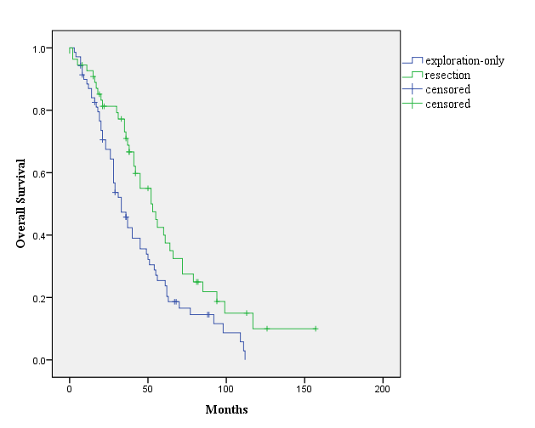
Fig 1. Overall survival (OS) curves stratified to whether pulmonary resection was performed for non-small cell lung cancer with pleural seeding incidentally detected during surgery

