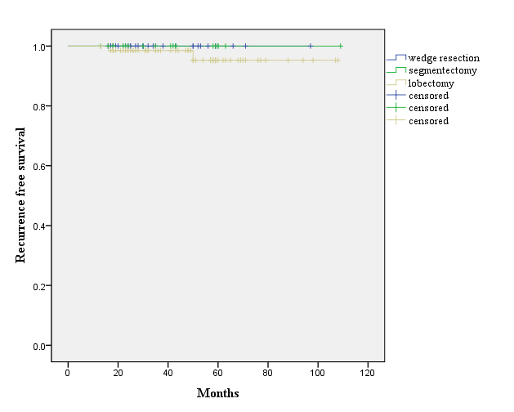
Fig 1. Recurrence-free survival (RFS) curves for patients with T1a radiographically noninvasive adenocarcinoma of the lung, which shows a C/T ratio$≤$0.25 according to the surgical strategy

