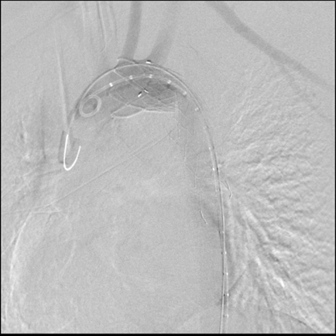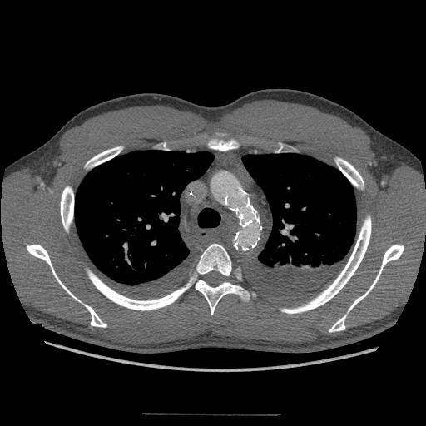
Fig. Aortography and CT show bent like web (arrow) by the stent wire and aortic stenosis.

