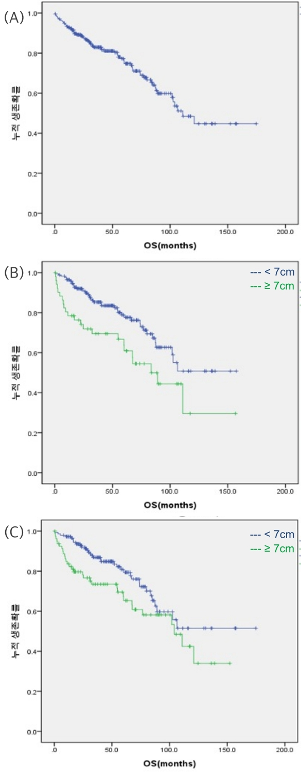
Figure 1. Kaplan-Meier analysis of overall survival (A), Survival curves by the tumor size on initial chest CT (B) and pathology (C) (tumor size of 7cm or greater versus less than 7cm)
Log-rank
P=0.036
Log-rank
P=0.009
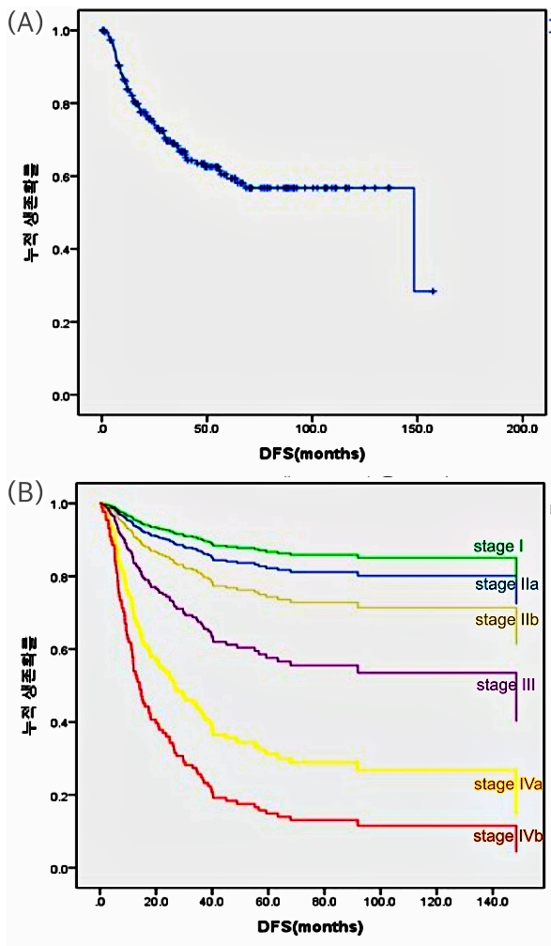
Figure 2. Kaplan-Meier analysis of disease-free survival (A), disease-free survival curves by pathologic Masaoka-Koga stage system (B).
Log-rank
P=0.000
Table 1. Univariate Analysis of Prognostic Factors for Overall and Disease-Free Survival
Characteristics | N=239 | Overall survival  HR (95% CI) p-value |  | N=192 | Disease-Free Survival  HR (95% CI) p-value
Age  ≥ 65 years | 76 | 1.76 (1.08-2.86) | 0.023 | 65 | 0.47 (0.26-0.85) | 0.013
Gender  Female | 80 | 0.55 (0.31-0.97) | 0.039 | 66 | 0.83 (0.49-1.39) | 0.472
Initial tumor size on CT  ≥ 7cm | 52 | 1.97 (1.18-3.29) | 0.01 | 35 | 1.57 (0.94-2.64) | 0.087
pathologic Masaoka-Koga stage  I  IIa  IIb  III  IVa  IVb | 20  28  36  86  31  35 | ref.  1.24 (0.21-7.40)  3.18 (0.7-14.6)  2.76 (0.65-11.68)  3.95 (0.87-17.83)  5.86 (1.34-25.72) | 0.039  ref.  0.817  0.136  0.167  0.074  0.019 | 20  27  32  68  18  25 | ref.  0.79 (0.16-3.97)  1.59 (0.41-6.22)  2.96 (0.89-9.81)  5.21 (1.37-19.88)  9.86 (2.87-33.84) | 0.000  ref.  0.778  0.504  0.076  0.016  0.000
Surgical approach  Sternotomy  Thoracotomy  VATS  others | 170  17  45  6 | ref.  0.59 (0.21-1.62)  0.18 (0.04-0.74)  0.39 (0.05-2.83) | 0.064  ref.  0.303  0.017  0.351 | 133  11  42  6 | ref.  1.79 (0.77-4.17)  0.48 (0.26-1.06)  0.68 (0.16-2.91) | 0.112  ref.  0.179  0.072  0.596
Complete resection  Yes | 192 | 0.62 (0.37-1.06) | 0.082
Lymph node dissection  Yes | 106 | 1.3 (0.8-2.11) | 0.279 | 86 | 1.82 (1.12-2.94) | 0.016
Pathologic tumor size  ≥ 7cm | 81 | 1.68 (1.03-2.74) | 0.039 | 57 | 1.57 (0.94-2.64) | 0.087
Hitology  Low grade  High grade  other | 189  15  26 | ref.  1.27 (0.54-2.97)  1.32 (0.64-2.70) | 0.682  ref.  0.587  0.450 | 156  11  17 | ref.  0.40 (0.09-1.66)  1.17 (0.50-2.71) | 0.410  ref.  0.206  0.717
Preoperative therapy  Yes | 47 | 1.46 (0.83-2.57) | 0.191 | 30 | 2.26 (1.3-3.92) | 0.004
Postoperative therapy  Yes | 181 | 1.18 (0.63-2.21) | 0.608 | 125 | 0.69 (0.43-1.13) | 0.143

