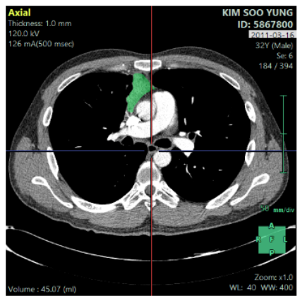
Figure 1. In neoadjuvant group, tumor volume was significantly decreased. (A) Initial chest CT shown large sized tumor volume. (B) Post-neoadjuvant chest CT shown significant decreased tumor volume.
(B)
(A)

