A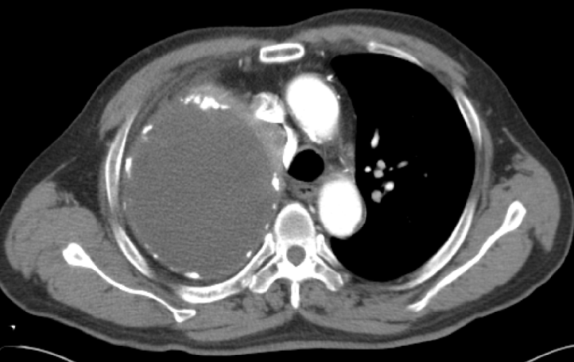 | B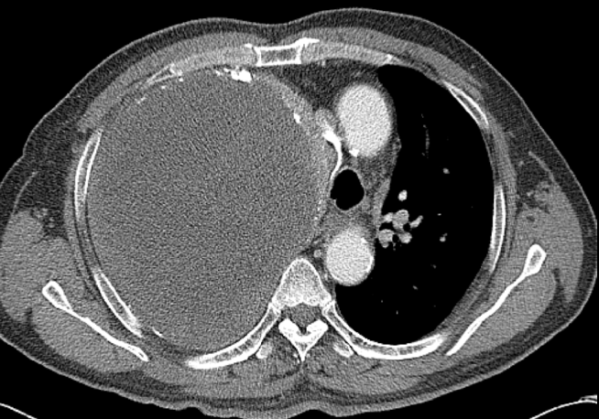
Fig 1. Preoperative chest ct. A: in 2007, chest CT showed the huge empyema occupating the whole right pleural cavity not disturbing adjacent structures such as trachea, superior vena cava, and azygos vein. B: in 2016, following-up chest ct showed the larger empyema inducing shifting of the trachea to the left and compressing SVC and azygos vein entirely.

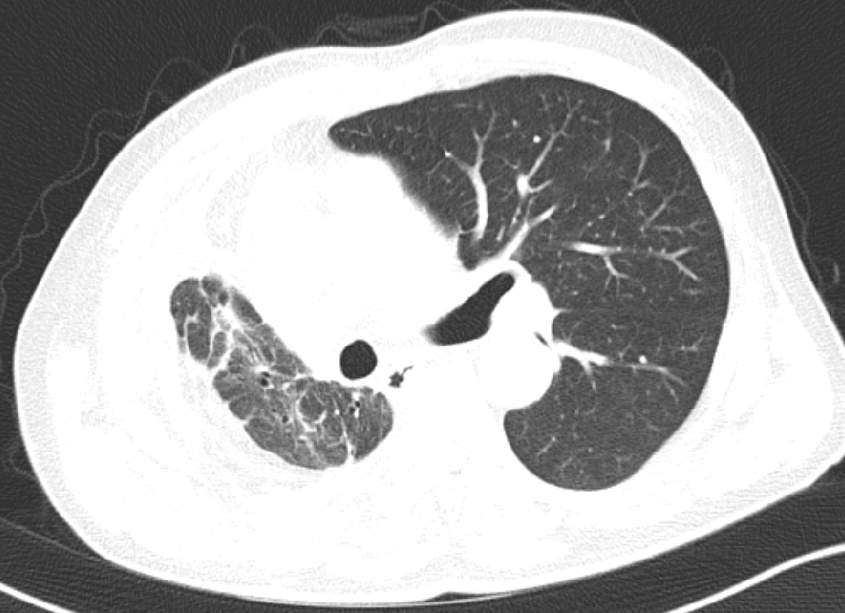
Fig 2. Chest CT at post-operative 8 months showed no post-operative complications except fibrotic scar change.

